A person of mass m_{p} stands on a scale in an elevator of mass m_{e} . The scale reads the magnitude of the force F exerted on it from above in a downward direction. Starting at rest at t=0 the elevator moves upward, coming to rest again at time t=t₀. The downward acceleration of gravity is g. The acceleration of the elevator during this period is shown graphically above and is given analytically by
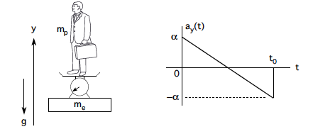
a_{y}(t) = α – 2αt₀ / t
a) Find the maximum speed of the elevator. Express your answer in terms of α and t₀

v_{y,max} =

b) Find the total distance traveled by the elevator. Express your answer in terms of α and t₀
y(t₀)=

