During a track event two runners, Mary, and Alice, round the last turn and head into the final stretch with Mary a distance d = 4.0 m in front of Alice. They are both running with the same speed of v₀= 5.0 m/s. When the finish line is a distance L= 45.0 m away from Alice, Alice accelerates at a_{A} = 1.5 m/s² until she catches up to Mary. Alice then continues at a constant speed until she reaches the finish line.
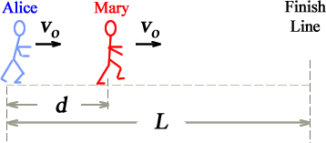

(a) How long (in s) did it take Alice to catch up with Mary?

(b) How far (in m) did Alice still have to run when she just caught up to Mary?

(c) How long (in s) did Alice take to reach the finish line after she just caught up to Mary?

Mary starts to accelerate when Alice just catches up to her, and accelerates all the way to the finish line and crosses the line exactly when Alice does. Assume Mary's acceleration is constant.

(d) What is Mary's acceleration (in m/s²)?

(e) What is Mary's velocity at the finish line (in m/s)?

