(adapted from www.funsci.com/fun3_en/electro/electro.htm#3)
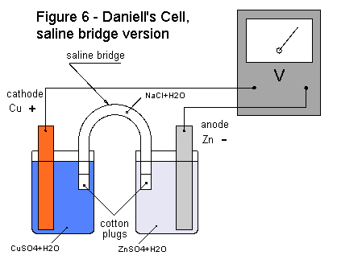
Kit Materials:
- 2 strips of copper
- 2 rods of zinc
- 4 50 ml flasks
- 2 U-tubes
- 1 cotton ball
- 1 multimeter
- 4 cables with alligator clips
- steel wool
- 1 plastic cup
- 1 disposable pipette
- 1 LED
- 2 gloves
Class items:
- 750 mL 1M Copper Sulfate (CuSO₄)
- 750 mL 1M Zinc Sulfate (ZnSO₄)
- 500 mL 1M Magnesium sulfate (MgSO₄)
- 2 funnels
- Clean your copper and zinc electrodes with steel wool (use gloves to prevent getting slivers of steel wool in your fingers).
- Pour 40-50 mL of the CuSO₄ solution into one flask and 40-50 mL of the ZnSO₄ solution into the other. Place the Zn rod into the ZnSO₄ solution and the Cu strip into the CuSO₄ solution.
- Prepare a salt bridge by placing a wad of cotton in one end of a U-tube and filling the tube with the magnesium sulfate solution being careful not to introduce any bubbles. Once the U-tube is full, put another cotton wad into the other end and invert it into the flasks, one end in each flask.
- Connect the voltmeter to the two electrodes and record the voltage you get. You should find it to be about 1.1 volts. This cell however doesn’t output much power. You would need electrodes with much greater surface area and more concentrated electrolyte to be able to power a very small light bulb with this device. Try instead an LED.
How does the Daniell's Cell work? As you have seen, the reactions at the electrodes furnish charges that allow the battery to produce electrical current for extended periods. In the Daniell's Cell, the copper strip attracts electrons from the zinc strip. These electrons pass through the wires of our external circuit. As the copper electrode receives electrons, free positive ions in the solution arrive to equalize the charges. Positive copper ions (Cu⁺⁺) are attracted to the charged copper electrode where they receive two electrons and become neutral and deposit on the electrode in metallic form. The positive zinc ions (Zn⁺⁺) move towards the salt bridge. For each copper atom that is deposited on the copper electrode, a zinc atom gives up two electrons to the zinc electrode goes into solution as a positive zinc ion.
The reactions at the electrodes can be represented by this formula:
Zn   Zn⁺⁺ + 2e⁻
Cu⁺⁺ + 2e⁻ Cu
These reactions result in the dissolution of zinc atoms in their ionic form, which corresponds to the deposition of copper ions in their metallic form:
Zn + Cu⁺⁺ Zn⁺⁺ + Cu
The electrons made available by the zinc atoms can pass through a lamp filament, produce light and eventually reach the copper electrode. These electrons account for the current that is produced by the battery and is used by the lamp. If we didn't have the salt bridge separating the two electrodes, the Cu⁺⁺ ions would go directly to the zinc electrode and pick up free electrons, thereby bypassing the external circuit and stopping the current flow through the wires and lamp. The battery would no longer work. Because the copper electrode attracts electrons from the external circuit, it is considered the positive pole of the battery.
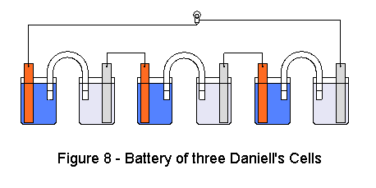
In a battery, there is always a flow of electrons in the external circuit (the electrical circuit or device) and a corresponding flow in the internal circuit (the electrolytic circuit). Like any battery, the Daniell Cell does not last forever, but only as long as there are Cu⁺⁺ions available and the zinc electrode is not consumed. In reality, the production of current diminishes as the concentration of the electrolyte bathing the zinc electrode increases and that bathing the copper electrode decreases. In fact, the positive ions produced by the zinc electrode need SO₄ ions to balance the charges. The exact opposite occurs in the copper solution, which becomes scarce of positive ions.
Since the voltage of a battery depends not only upon the nature it's components, but also upon the concentration of it's electrolytes, the concentration changes that result from the production of electricity causes the battery to generate lower and lower voltages and currents until finally it is considered dead. At the end, Zn⁺⁺ ions finally reach the copper electrode, surrounding it and blocking any further movement of Cu⁺⁺ ions by polarizing the electrode
If you want higher voltages, you can connect multiple Daniell Cells in series as shown in figure 8. Note that between one cell and another, the connection is a metallic wire rather than a saline bridge.
Once you have successfully constructed your cell, complete the following:
- What do you think will happen if you place a strip of copper into the ZnSO₄ solution? Try it. What happened? Why?

- What do you think will happen if you place a piece of zinc into the CuSO₄ solution? Try it. What happened? Why?

- Try to light an LED with your battery. Add more batteries in series (see figure 8) until the light works. How many did it take? What is the voltage for this number of cells?

- Build a cell using a 0.1 M solution of CuSO₄ (dilute your 1M solution 10 to 1). What is the voltage for this cell? Why do you think it is different?

