- Fill in the table for this circuit. Show your work and then check your answer with PhET

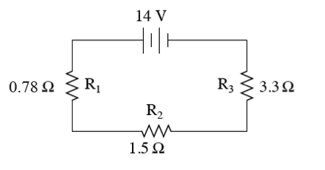
 | R₁ | R₂ | R₃ | Total
V
I
R | 0.78 Ω | 1.5 Ω | 3.3 Ω
P

- A parallel circuit has 3 resistors each on different paths connected to a 120 V potential difference. The resistors have resistances of 5.0 Ω, 7.5 Ω, and 9.8 Ω. Draw a picture of the circuit in the box and fill in the table for this circuit. Show your work and then check your answer with PhET.

Add units to measurements | 5.0 Ω | 7.5 Ω | 9.8 Ω | Total
V ( )
I ( )
R ( )
P ( )

- For both circuits: Determine the potential difference (voltage) across and the current (amps) through each resistor. Show your work and then check your answer with PhET
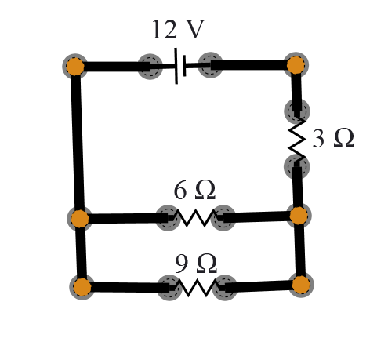
 | R₁ = 3 Ω | R₂ = 6 Ω | R₃ = 9 Ω
Voltage (volts)
Current (amps)

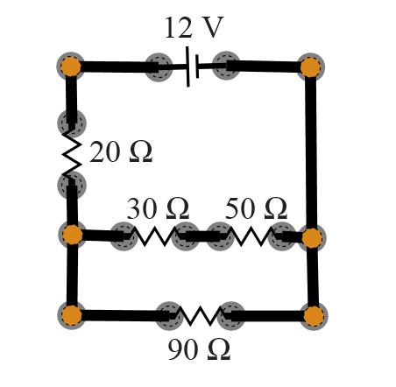
 | R₁ = 20 Ω | R₂ = 30 Ω | R₃ = 50 Ω | R₄ = 90 Ω
Voltage (volts)
Current (amps)

- Construct a complex circuit with 2 resistors in series and 2 in parallel that will produce _________total resistance using PhET. Draw your schematic diagram in the box below. (Hint: there are several correct designs).
Use a 9 V battery and one of each of the resistors: 220 Ω, 100 Ω, 50 Ω, 40 Ω

